Ideation Phase
Brainstorm & Idea Prioritization Template

Date | 13 July 2026
Team ID | SWTID-2026-4732
Project Name | India's Agricultural Crop Production Analysis
Maximum Marks | 4 Marks

Brainstorm & Idea Prioritization Template:
The brainstorming session focused on developing an interactive Tableau dashboard for analyzing India's agricultural cultivation data from 1997 to 2021. Team members suggested ideas related to crop production analysis, state-wise comparison, seasonal trends, dashboard design, data visualization, and interactive features. These ideas were carefully discussed, grouped into meaningful categories, and evaluated based on their importance and feasibility. These selected ideas formed the foundation for the dashboard development and ensured that the final solution effectively supports farmers, government agencies, and agribusiness investors in making informed decisions.
Step-1: Team Gathering, Collaboration and the Problem Statement
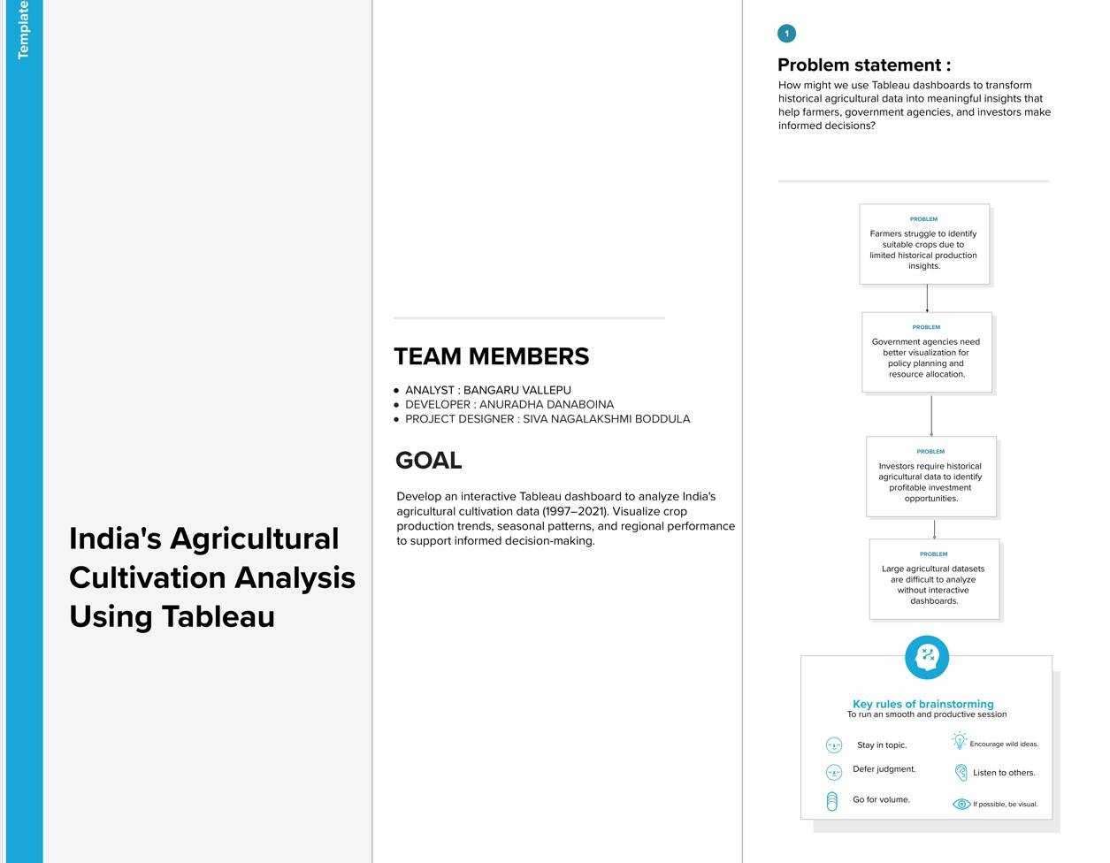

Step-2: Brainstorm, Idea Listing and Grouping
After listing all the ideas, similar concepts were grouped into meaningful categories such as Data Analysis, Dashboard Development, and Visualization. This grouping process helped organize the ideas systematically and made it easier to evaluate and prioritize the most effective solutions for the project.
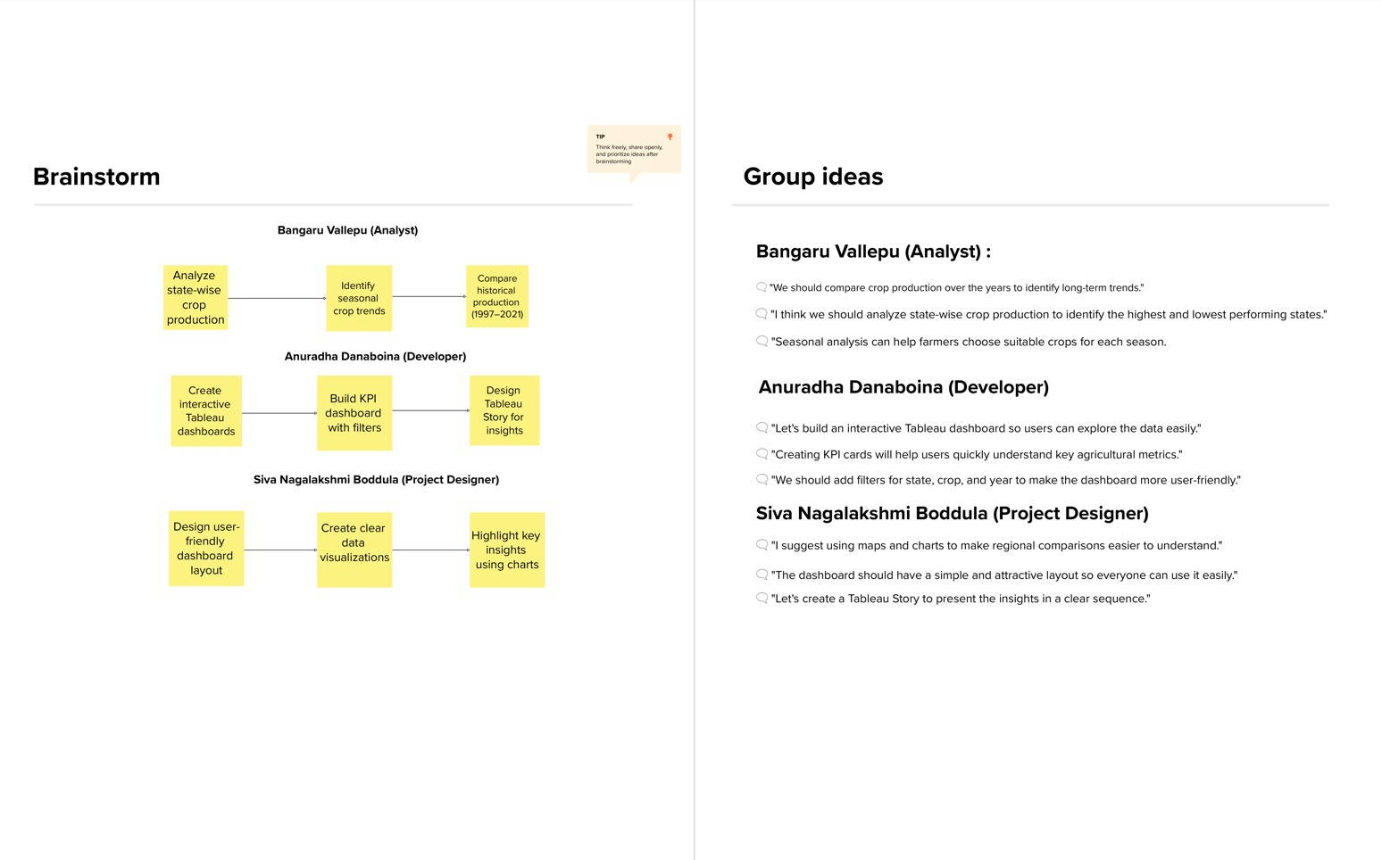
Step-3: Idea Prioritization
The brainstormed ideas were prioritized using an Importance vs. Feasibility approach. Ideas that offered the highest value and could be implemented effectively within the project scope were selected. This process helped the team focus on developing the most impactful features for the Tableau dashboard.
